We’re back!!!!
You are cordially invited to the 18th Annual
‘HOLIDAY HAPPENING’ LUNCHEON
Saturday, Dec. 3, 2022 at 10:00 AM
At St. Joseph’s Center,
151 E. State Street, Adams, WI
Presented by
Adams County Historical Society
This year’s theme is:
‘I REMEMBER WHEN…Celebrating Memories”
We wish to celebrate the many events we all have had in our past that we look back on as milestones in our lives. Some shared with family and friends, some of our own but each helped make us who we are. Some from childhood, others as we became adults, still others that occurred around us. The past two years a few of our decorators created an online HAPPENING, some of you may have seen, This year we can finally do it in person!
So, have fun planning your tables! We all enjoy the variety of décor and themes! As always…ANYTHING GOES you don’t HAVE to follow our theme.
You can choose to invite friends, family, spouses, children and grandchildren (the minimum age is 5) or you may participate as a club, organization or business.
Our lunch will again be served on clear plastic plates, so your dinnerware won’t be soiled. However, you will be using your flatware, glassware, cups, and linens. So, we recommend that you transport your items in sturdy boxes or plastic bins. It is also suggested that you include paper towels for ease in clearing your items to take home. There will be table space to display brochures or information that you may wish to share with other attendees.
SET-UP TIME is from 8:00am until 10:00am that day, with guests and attendees welcome after 10:00am. You may pre-arrange to set up the evening before by calling Pat at 608-548-2199

Table sizes are ALL 36” x 96”. Table number is assigned in the order received. If you need electricity available please indicate on the reservation form. Remember: There is limited space available!

To reserve a table to decorate, please fill out and return the attached form to the address indicated and include $25.00 for each participant or $200.00 per table. Groups requesting décor done by the Society will be $25.00 per person.Individuals may reserve seating at Society tables for $25.00 each.

We ask that you return your reservation forms by Nov. 29th. If you have seats you cannot fill, please let us know so we can fill them with individuals who may need a seat. Note: The Society has a number of sets of dishes, & glassware available to be used by participants if they wish to use them and add their own decorations. Questions? Contact Pat Kierstyn at 608-548-2199…

WE ARE PLEASED THAT SO MANY IN OUR COMMUNITY SUPPORT US. WHEN YOU CELEBRATE WITH US, YOU ARE ALL PART OF OUR HISTORY!

A sampling of previous years tables
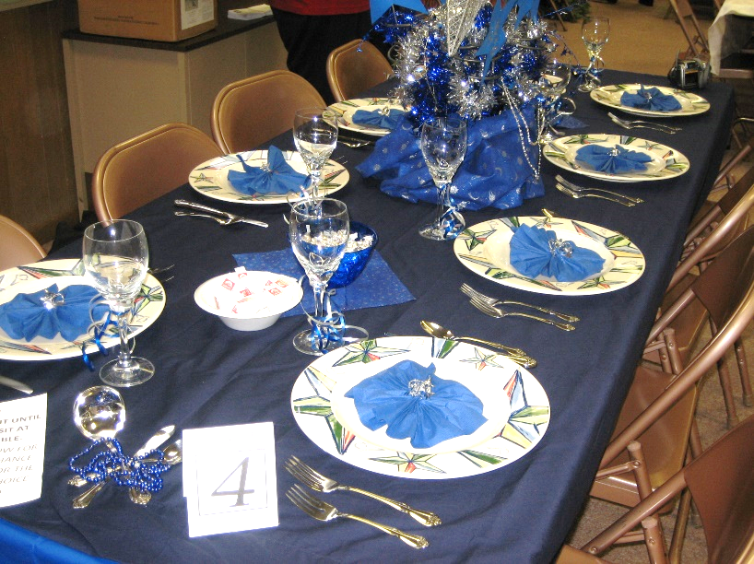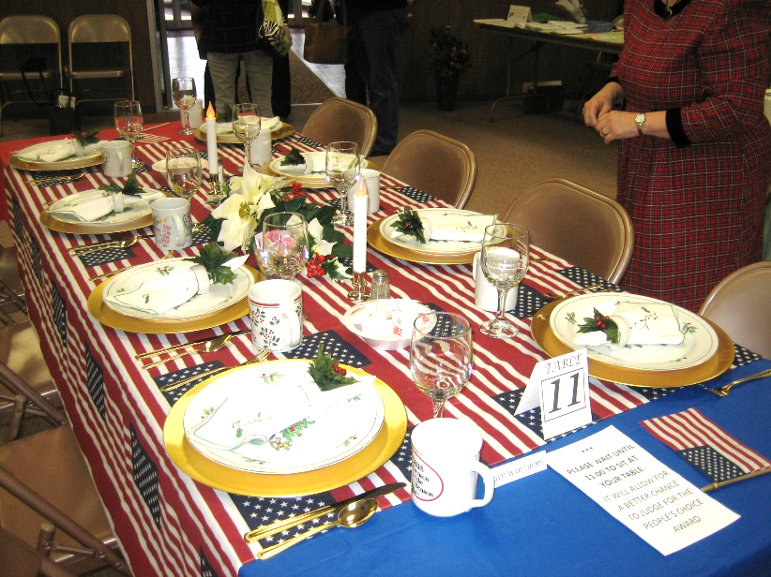
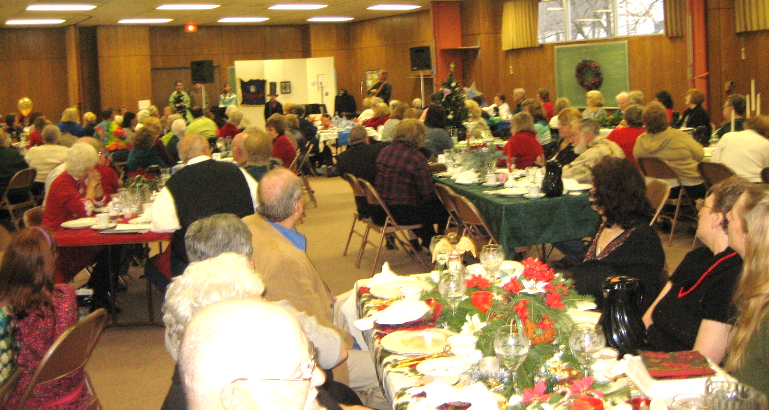
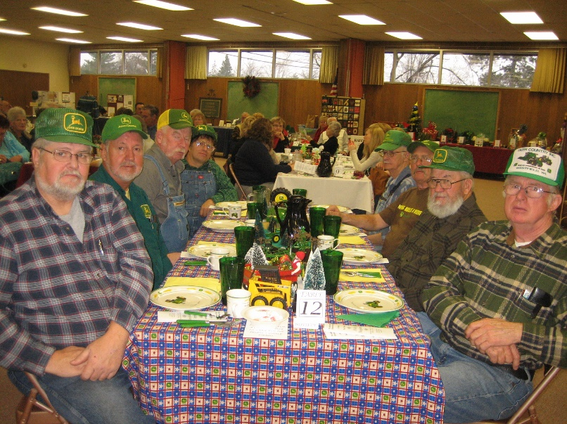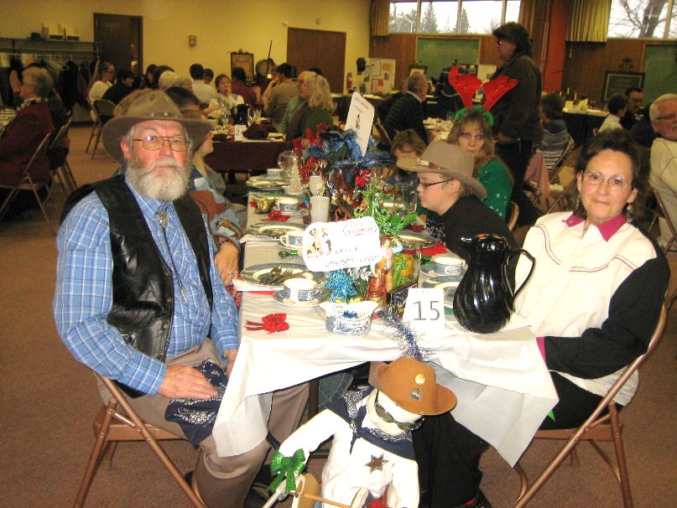

TABLE RESERVATIONS FORM
“2022 Holiday Happening”
Theme: “I REMEMBER WHEN…Celebrating Memories”
Saturday, Dec. 3, 2022, 10:00 am to 2:00pm
(Setup: 8am to 10am Sat.)
Table Sponsor:_______________________________________________ ContactPerson:_______________________________________________
Address:____________________________________________________
City:____________________________________________ ST:________
Zip:______________
Phone:(____)______-______________
Email:______________________________________________________
Decorator(s):__________________________________________
____________________________________________
Table Theme:__________________________________ ____________________________________
Number of guest tickets:____ x $25.00 = total $__________
Number of Society décor tables guest tickets:_____x $25 = total$__________
Your tickets may be picked up at the registration table the day of the event. Return this form and check(s) before Nov. 28, 2018 to: Adams County Historical Society , Box P.O. Box 264 , Friendship, WI 53934
(Or you may drop them off at the Heritage Center on Tues and Thurs, from 12-5pm.)

If you wish to be interviewed about your table theme, please choose a Designated Spokesperson:
________________________________________________

CUT----------------------------------------------------------------------------------------------------------------------------------------------------------------------
TABLE RESERVATIONS FORM
“2022 Holiday Happening”
Theme: “I REMEMBER WHEN…Celebrating Memories”
Saturday, Dec. 3, 2022, 10:00 am to 2:00pm
(Setup: 8am to 10am Sat.)
Table Sponsor:_______________________________________________ ContactPerson:_______________________________________________
Address:____________________________________________________
City:____________________________________________ ST:________
Zip:______________
Phone:(____)______-______________
Email:______________________________________________________
Decorator(s):__________________________________________
____________________________________________
Table Theme:__________________________________ ____________________________________
Number of guest tickets:____ x $25.00 = total $__________
Number of Society décor tables guest tickets:_____x $25 = total$__________
Your tickets may be picked up at the registration table the day of the event. Return this form and check(s) before Nov. 28, 2018 to: Adams County Historical Society , Box P.O. Box 264 , Friendship, WI 53934
(Or you may drop them off at the Heritage Center on Tues and Thurs, from 12-5pm.)

If you wish to be interviewed about your table theme, please choose a Designated Spokesperson:
________________________________________________

